Fast**National University of Computer & Emerging Sciences, Karachi  
Fall-2020 - Department of Computer Science**

|  |  |
| --- | --- |
| **Course Code: CS211** | **Course Name: Discrete Structures** |
| **Instructor Names: Dr. Fahad Samad, Mr. Shoaib Raza and Ms. Bakhtawar Abbasi** | |
| **Student Roll No:** | **Section No:** |

**Bachelor of Science (Computer Science)  
Re-Midterm 2 Examination - - Solution  
December 17, 2020, 01:15 pm – 02:15 pm**

**Instructions:**

* Return the question paper together with the answer script. Read each question completely before answering it. There are **3 questions and 2 pages.**
* In case of any ambiguity, you may make assumption. But your assumption should not contradict any statement in the question paper.
* Attempt all the questions in given sequence of the question paper.

__________________________________________________________________________________________________________________________________________________________________________________________**Total Time**: 60 minutes **Maximum Marks**: 24

**Question # 1 (Relations) [ 2+2+2+2 = 8 Marks]**

(a) Find the smallest relation on {1, 2, 3}, that is Asymmetric and Transitive, but not Symmetric.

Solution:

R = {(1, 2)}

(b) Determine whether the relation in part (a) is a Partial-order relation? Show all of your steps.

Solution:

No, it is not a partial order relation. Since it is not reflective.

(c) Represent the below Digraph in Matrix form.

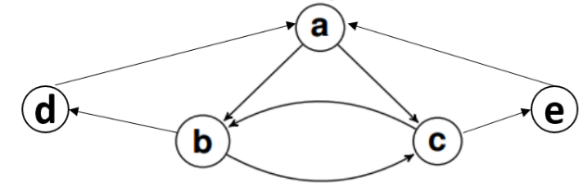Solution:

$$\left[\begin{matrix}\begin{matrix}0 \\ 0 \\ 0\end{matrix} & \begin{matrix}1 \\ 0 \\ 1\end{matrix} & \begin{matrix}\begin{matrix}1 & 0 & 0\end{matrix} \\ \begin{matrix}1 & 1 & 0\end{matrix} \\ \begin{matrix}0 & 0 & 1\end{matrix}\end{matrix} \\ 1 & 0 & \begin{matrix}0 & 0 & 0\end{matrix} \\ 1 & 0 & \begin{matrix}0 & 0 & 0\end{matrix}\end{matrix}\right]$$

(d) Determine whether the relation in part (c) is an Equivalence relation? Show all of your steps.

Solution:

No, it is not an Equivalence relation. Since it is not reflective, Symmetric and Transitive.

**Question # 2 (Graph Theory) [ 2+2+2+2 = 8 Marks]**

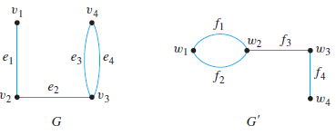(a) Determine if the following two graphs ***G and G’*** are isomorphic. If they are, give function ***f: V (G) → V (G’)*** that define the isomorphism. If they are not, give the reason why?

Solution:

Function f: V (G) →V (G/):

*f(v1) = W4*

*f(v2) = W3*

*f(v3) = W2*

*f(v4) = W1*

(b) Find if the given graph is bipartite or not. Redraw the bipartite graph so its bipartite nature is evident.

Solution:

Yes, graph is bipartite. B1(a, b, d) & B2(c, e, f, g)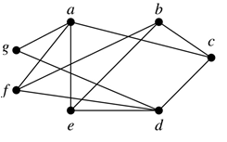

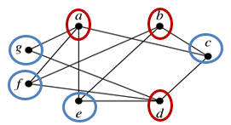

(c) Find the length (sum of weights) of a shortest path between a and z in the given weighted graph by using Dijkstra’s Algorithm.

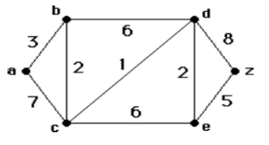Solution: The length of shortest path from a to z is 13.

|  |  |  |  |  |  |
| --- | --- | --- | --- | --- | --- |
| **Node** | **D(b)** | **D(c)** | **D(d)** | **D(e)** | **D(z)** |
| **A** | **3,a** | **7,c** | ∞ | ∞ | ∞ |
| **ab** |  | **5,b** | **9,b** | ∞ | ∞ |
| **abc** |  |  | **6,c** | **11,c** | ∞ |
| **abcd** |  |  |  | **8,d** | **14,d** |
| **abcde** |  |  |  |  | **13,e** |
| **abcdez** |  |  |  |  |  |

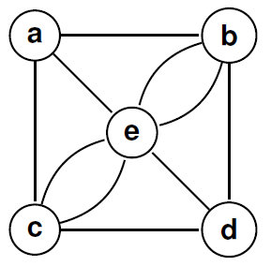(d) Determine if Euler and Hamilton circuits exist in given below graph***.*** If yes, show the circuit, if not explain why?

Solution:

Euler circuit don’t exist as vertex a & d have degree 3.

Hamilton circuit exists which are:

H1: a,b,d,c,e,a; H2:a,c,d,e,b,a; H3:a,e,c,d,b,a

**Question # 3 (Number Theory) [ 4+2+2 = 8 Marks]**

(a) A general counts the number of surviving soldiers of a battle by aligning them successively in rows of certain sizes. Each time, he counts the number of remaining soldiers who failed to fill a row. The general initially had 1500 soldiers before the battle. After the battle

aligning them in rows of 5 soldiers leaves 3 remaining soldiers;

aligning them in rows of 6 soldiers leaves 3 remaining soldiers;

aligning them in rows of 7 soldiers leaves 1 remaining soldier;

aligning them in rows of 11 soldiers leaves 0 remaining soldiers.

How many soldiers survived the battle? Solve this problem using Chinese Remainder Theorem.

Solution:

x ≡ 3 (mod 5) x ≡ 3 (mod 6) x ≡ 1 (mod 7) x ≡ 0 (mod 11)

We will follow the notation used in the proof of the Chinese remainder theorem.

We have m=m1 * m2 * m3 * m4 = 2310.

Also, by simple inspection we see that:

y1 = 3 is an inverse for M1 = 462 modulo5,

y2 = 1 is an inverse for M2 = 385 modulo 6,

y3 = 1 is an inverse for M3 = 330 modulo 7 and

Y4 = 1 is an inverse for M3 = 210 modulo 11.

The solutions to the system are then all numbers x such that

x = (a1M1y1 + a2M2y2 + a3M3y3 + a4M4y4) mod m

= ((3 * 462 * 3) + (3* 385* 1) + (1* 330* 1) + (0*210*1)) mod 2310 = 5643 (mod 2310) = 1023.

Hence 1023 soldiers survived the battle.

(b) After counting the number of soldiers survived, the army general communicated this to head office using Ceaser Cipher. What will be the Encrypted Number Word?

Solution:

Number Word: One thousand and twenty three

Encrypted Number word: RQH WKRXVDQG DQG WZHQWB WKUHH

(c) Suppose that a computer has only the memory locations 0, 1, 2. . . 63. Use the hashing function h(x) = (x + 7) mod 64 to determine the memory locations at which the following values are stored:

63, 518, 176, 832, and 652.

Solution:

63 will be stored on memory location 6, 518 will be stored on memory location 13,

176 will be stored on memory location 55, 832 will be stored on memory location 7, and

652 will be stored on memory location 19.